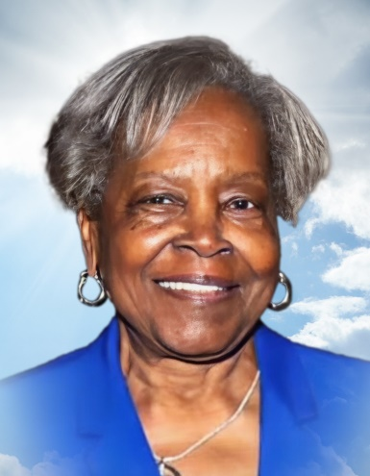**(February 26, 1947 - June 20, 2024)** “To god be the glory for the things he has done.” On February 26, 1947, Mr. and Mrs. Willie H (Janie R.) Caughman gave birth to their first children, a set of twin girls. The first one they named Arneita Delores and the other Juanita Doris. On Thursday, June 20, 2024 , Arneita who gained the title of “Matriach” went home to be with her Lord and Savior. At the early age of 12 years old, Arneita was baptized by Rev. M.J. Odom and became a member of Central Baptist Church. She grew up in Sunday school, youth choir, vacation bible school, and other youth activities within the church. During her older years , she sang with the Ronald D. Barton Mass Choir and the Voices of Praise Choir. Arneita was a 1966 graduate of Booker T. Washington High School. She participated with the John W. Works Chorus , and she also learned the skill of cooking. She practiced this skill as a caterer for many activities in Columbia and surrounding areas. She enjoyed serving on the Culinary Committee at Central Baptist Church. In 1967, Arneita married the “Love of Her Life ,” Mr. Eugene Phelps (aka Snook). This marriage lasted for 48 years, and they became the proud parents of three daughters, LaHartha, Stephanie, and Precious. Arneita was employed with Horseman Dolls in the assembly department for over 10 years. She was the cafeteria manager for Food Services Incorporated for over 20 years working at Robert Bosch , in Charleston SC, and Bose, in Columbia SC. After retirement , she was an in -home babysitter for children, from infant to 3 years old. Arneita was preceded in death by her parents ; her husband ; and her brothers, Willie H. Caughman , Jr. and Stephen W. Caughman. Left to share her fond memor y are : her three daughters, LaHartha Phelps, Stephanie (Corey) Phelps -Sinkler, and Precious Breeland; her grandchildren, Kori Sinkler, Camryn Laurie, and Kendell Sinkler; her siblings, Juanita D. Pagan (her twin), Patricia (Allen) Colter, Larry (Brenda) Caughman, Sharon A. Caughman, Andrena (Stanley) Scott, Altheia(James) Gibson, and Tara (Glen) Savage, sister - i n - law , Yvonne Phelps ; brother -in -law, Lee Lawson; special niece, Tonya Phelps; god children, Bernardra Scott, Khari and Khamari Dowdy, and Sir Khiland Small; bonus daughters, Donna Johnson, and Taisha Green; bonus son, SFC ( Retired ) Fredrick Carpenter; bonus grandson , Gary Monroe; many nephews, nieces, great -nephews, great -nieces, great -great -nephews and nieces ; a hosts of cousins and friends, all of who m will miss her dearly. We thank God for 77 blessed years in the presence of our mom, sister, grandma, aunt, cousin, friend, and our “Matriarch.”