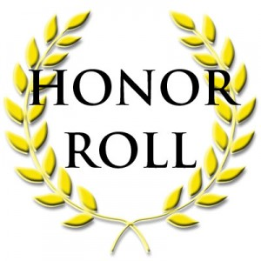
HONOR ROLL
4TH Marking Period
2017-2018 School Term

Principal’s List
Kendrell Chambers
Jazmine Gillie
Kyndall Riley

“A” Honor Roll
Charles Brooks IV
Julia Brooks
Laneshia Brown
Precious Breeland
Natalie Geddis
Laurin Hannibal
Nasir Jackson
Sidney Johnson
Feasia Lake
Christian McDaniel
Elizabeth McDaniel
Kamryn Nesbitt
Jaylen Phillips
Shayla Phillips
Charles Price
K’Yah Scott
I’Rihaunna Wheatle

“B” Honor Roll
Jada Brooks
John Hannibal Jr.
JaQuan Johnson
Zari Lake
Camryn Laurie
Nicholas McDaniel
Jayla Porterfield
Talia Pugh
Jason Rembert
Myracle Slaughter

