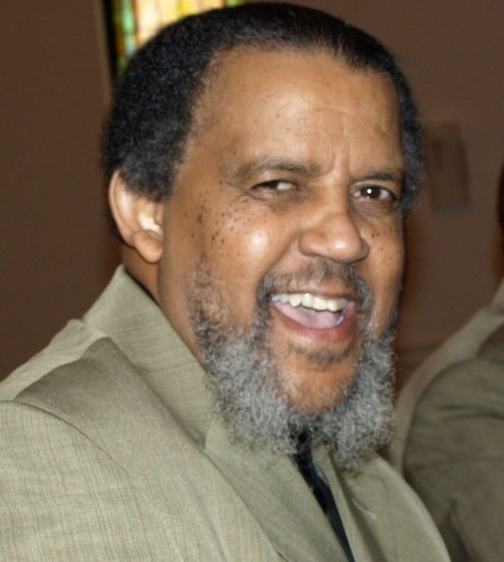

Mr. Clark Williams

Aug 1, 1949 - Aug 14, 2016
Deacon Clark Williams was born in Port Arthur, Texas on August 1, 1949 to the late Clarence and Estelle Williams. He departed this earthly journey on Sunday, August 14, 2016 in Columbia, South Carolina.
Surviving are his loving wife of 44 years, Lou Ella Williams; one son, Derrick L. Williams; one daughter, Joy Williams Price; two grandsons, Derrick L. Williams and Charles Ray Price II; four sisters, Eva Mae Anderson, Louise Williams, Leola Williams, and Leila Wilson; son-in-law, Charles R. Price; special family friends, Mae V. Pate and Patricia Robinson along with a host of other loving relatives and friends.

Funeral Service
Central Baptist Church
Thursday August 18th, 2016
12:00pm
3625 Clement Road
Columbia, SC 29203

