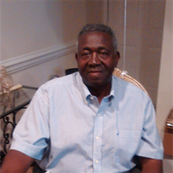Obituary for Deacon Julius Caesar Hampton

Born June 6, 1946, in Columbia, South Carolina, Deacon Julius Caesar “Pokey” Hampton left earth for his Heavenly home in the early morning hours of December 2, 2016.
Growing up in the neighborhoods of Columbia and educated in its public schools, Deacon Hampton graduated from Booker T. Washington High School and found subsequent employment with Joseph Walker & Company as a cotton porter from which he retired after a lifetime of service. A strong believer in the saving grace of Jesus Christ, Deacon Hampton was ordained at Central Baptist Church where he faithfully discharged his duties; he also sang with the Male Choir, often leading the Praise and Worship portion of the service as well as being a devoted Bible Study attendee.
Deacon Hampton leaves to cherish precious memories two daughters: Adriane Hampton (Olin) Boyd of South Carolina, and Dawn R. Hampton of Tennessee; four grandchildren: Randy S.K. Washington and Miracle Hampton, both of New York, and Chance S. Boyd and Blake A. Boyd, both of South Carolina; two sisters: Willie C. Frazier and Johnnie Mae Chisholm; one brother, Freddie Lee Hampton; one maternal aunt, Katherine Montgomery Hudson; a special friend, Lena Mae Hunter; a godson, Robert Montgomery; one reared in the home loved one, Crystal Hampton; and a host of other loving relatives and friends, all of whom will dearly miss his presence.

