George Hampton, Jr.
April 22, 1930 ~ June 29, 2017 (age 87)
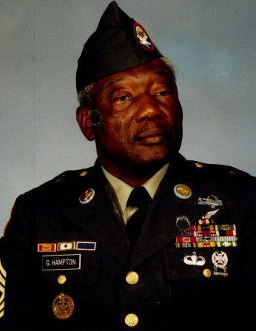
Deacon George Hampton, Jr. was born April 22, 1930 to Mr. and Mrs. George Allen and Anna Green Hampton in Orangeburg, South Carolina. He left his earthy dwelling and entered eternal rest to be with the Lord on June 29, 2017. In addition to his parents, Deacon Hampton was predeceased by his brothers Roy, Glen and Ezekiel Hampton, and sister, Adele Brooker.
A highly decorated soldier, George was in the United States Army, serving during both the Vietnam and Korean Wars. After many years of honorable service, he retired as a Sergeant First Class. He was a member of the VFW Lodge #4262 and the American Legion.
George was a faithful member of Central Baptist Church where he served as a deacon for 20 years, until his death.
He leaves to cherish memories: his wife of 29 years, Robin Hampton; daughters, Shaquana Hampton of Atlanta, Georgia, Donna Haigler of Spartanburg, South Carolina, Ann Nottingham, Tangee (Anthony) McNeill, Kymberly and Tamika Hampton, all of Columbia, South Carolina; sons: Lamorris, Marvin (Lydia), Garvin (Renee) and George (Tonya) Hampton III, all of Columbia, South Carolina; sisters, Ella Mae Graham of Columbia, Maryland and Jannie Hampton of Buffalo, New York; and brothers, Solomon (Tina) Hampton of Fort Hamilton, Florida and Virgil Hampton of Manhattan, New York. He also leaves behind 15 grandchildren, one great-grandchild, a sister-in-law, Agnes Ruff; brothers-in-law, George and Anthony Gilmore; and a host of nieces, nephews and cousins who will miss him dearly.

