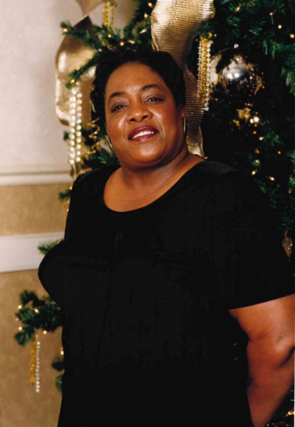

Martha Delores Pearson Kelly
December 28, 1948 ~ August 4, 2025 (age 76)
Obituary & Services

Martha Pearson Kelly Obituary
Martha Delores Pearson Kelly was born December 28, 1948, in Sumter, South Carolina, the beloved daughter of the late Marion Pearson Sr. and Emma Dow Pearson. Martha passed away peacefully at her residence on Monday, August, 4, 2025.
Martha was educated in the public schools of Sumter County where she graduated from Sumter High School in the Class of 1967. She worked at FN Manufacturers for 35 years from which she retired in 2019, after many years of dedicated service.
Her pleasant personality was contagious to everyone she met. The simplest pleasures in life brought extraordinary joy to Martha.
Though she is no longer physically with us, she has left a legacy of love to all those who loved and knew her.
In addition to her parents, Martha was preceded in death by, two sons; and ten brothers.
She is lovingly survived by her son, Byron Kelly of Columbia, SC; two granddaughters, Keia Kelly and Stacy Garcia, both of Arizona; two grandsons, Kia Kelly of Arizona, and Marquise Osborne of Philadelphia; great grandchildren8; her loving sister, Mary Pearson of Bronx, NY; a special niece, Renee Chapman of West Columbia, SC; and several cousins, nieces, nephews, and friends.
As we say goodbye to Martha P. Kelly, we celebrate the life of a woman who was a beacon of kindness and love. Her legacy is one of unwavering devotion to her family, a testament to the beautiful life she lived, and the countless lives she touched.
Martha's memory will be treasured forever, as we hold her close in our hearts and remember the light she brought into this world.

