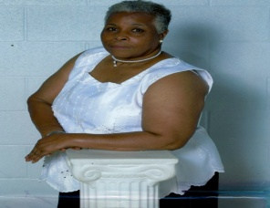

Patricia A. Van'Hannegeyn
March 7, 1943 ~ December 10, 2017 (age 74)
Ms. Patricia Brown-Van’Hannegeyn was born in March 7, 1942 in Charleston, South Carolina to the late William and Ethel Gary.

Patricia was educated in Charleston, South Carolina and New York City. Patricia was a loving and caring person to all she met. She had a gift for interior decorating and a passion for sewing and cooking.

She worked as a Certified Nursing Assistant for home health care and in Food Preparatory Services for the University of South Carolina.

Patricia was a longtime member of Central Baptist Church in Columbia. She was active with the Senior Missionary Society, Usher Ministry, and the Golden Voices Choir. She was also an active member with the united Order of Tents Chamber Beauty #60.

On December 10, 2017, Patricia had her ticket in hand.

Left to cherish her memories are her two daughters, Vanessa Brown-Wilson from Upstate New York and Angelique Van’Hannegeyn of Columbia, South Carolina; three sons, Keith Van‘Hannegeyn of Columbia, South Carolina, Kevin (Sonja) Van’Hannegeyn, and William (Tinkea) Van’Hannegeyn, both of Atlanta, Georgia; her sister, Ann Gary; fourteen grandchildren, twenty-eight great grandchildren, and two great-great grandchildren; and a host of loving cousins, nieces, nephews, and friends, all of whom will miss her dearly.

