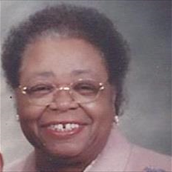

Obituary for Shirley H. Smith Harrison

Shirley H. Smith Harrison of 3116 River Drive departed this life on Saturday, September 10, 2016 at home with family.
Born January 11, 1939 in Columbia, South Carolina she was the daughter of the late John Henry and Alice Miley Highsmith. She attended the Richland District One Public Schools, graduating from C.A. Johnson High School. She completed the Surgical Technician Program at Columbia Hospital (now Palmetto Richland Memorial Hospital) and completed the required hours in the Supervisor and Management Programs at Clemson University and the University of South Carolina. She attended Benedict College for three and a half years majoring in Religion and Philosophy.
Those who will cherish fond and precious memories of Shirley are her beloved husband, Reverend Winslow Harrison, of the home; her loving and devoted daughter, Karen A. Smith of Columbia, South Carolina and stepson, Winslow Harrison, Jr of Baldwin, New York; a loving sister; two nieces; a cousin; her loving and caring goddaughter; the family pet Gizmo; and a host other loving relatives and dear friends, all of whom join the family in sharing grief caused by her departure, but rejoice that she is resting with the LORD.
Memorial gifts may be made to the SC American Heart Association, Central Baptist Church, and St. John Baptist Church Preschool.

