Stephen Wendell Caughman

(September 16, 1958 – January 4, 2018)
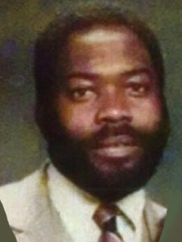
Viewing Date and Time: Wednesday, 01/10/2018 2:00 p.m.
Funeral Location: Central Baptist Church
Funeral Date and Time: Thursday, 01/11/2018,11:00 a.m.
Obituary Mr. Stephen Wendell Caughman was born on September 16, 1958 , in Columbia, South Carolina , to the late Willie H. and Janie Rickenbacker Caughman. He departed this earthly life on Thursday, January 4, 2018 , after an extended illness. Steve, as he was affectionately known , was educated in the Richland County Public Schools , and was a 1977 graduate of W. J. Keenan High School. He furthered his education at Patterson Barber College , where he became a Master Barber. He was known locally as one of the Best Barbers in Columbia. Steve joined Central Baptist Church at an early age. He enjoyed family, joking around, and music. His favorite group of all time was Frankie Beverly and Maze, songs “Southern Girl” and “Happy Feelings.” Mr. Stephen Wendell Caughman leaves to cherish his passing: one daughter, Timika (Andrew) Goyins; sons, Stephen Caughman, Travis (Kelli) Caughman; sisters, Arn eita Phelps, Juanita Pagan, Patricia (Allen) Colter, Sharon Caughman, Andrena (Stantley) Scott, Altheia (James) Gibson, and Tara (Glen) Savage, all of Columbia, South Carolina; brothers, Willie Caughman , Larry (Brenda) Caughman, both of Jacksonville, Florida, and Ronald Hart, of Winnsboro, SC; 8 grandchildren, a host of nieces, nephews, great - nieces, great -nephews, many other loving relatives and friends, all of whom will miss him dearly .

