Alice Dean Murphy
January 25, 1939 ~ December 20, 2018 (age 79)
Obituary
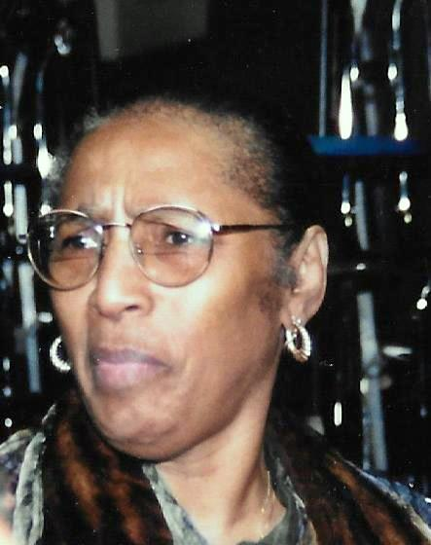
Mrs. Alice Dean Murphy
Columbia, SC: Mrs. Alice Dean Murphy, died on Thursday morning, December 20, 2018, at the home of her daughter, Lori R. Waring, after declining health.
She was born in East Meadow, New York, January 25, 1939, daughter of the late Simmie and Gladys Bell Dean. She was a graduate of Hempstead High School and did further studies at Nassau Community College and a retired accountant from BellSouth Communications (AT&T). She was a member of the Mine Creek Baptist Church and a life member of the NAACP.
At an early age, she joined South Hempstead Baptist Church and after moving to Columbia, SC, she joined Central Baptist Church and later in life she became a member of Mine Creek Baptist Church, Saluda, SC.
She was married to Eddie Murphy, Jr. who preceded her in death.
In addition to her parents and husband, she was also preceded in death by siblings; Simmie Robert Dean, Retie E. Myers and Annie M. Green and grandson, Derrick Nelson.
She is survived by: daughters, Lori (Darryl) Waring, Merial B. Hunter and Adrienne Butler all of Columbia, SC and Joyce L. Steele of Atlanta, GA; five grandchildren, six great grandchildren; one sister, Vickie Y. Tarvin of Columbia, SC; one aunt, Adrienne (Joe) Johnson, Passaic, New Jersey; in-laws; nieces, nephews, other relatives and friends.
Funeral Services will be 11:00 A.M. Friday, December 28, 2018 at First Nazareth Baptist Church, 2351 Gervais Street, Columbia, SC with burial in Mine Creek Baptist Church Cemetery, 1799 Johnston Highway, Saluda, SC. The day of service the body will be placed in the church at 10 A.M.
Butler and Sons Funeral Home is assisting the Murphy Family.

