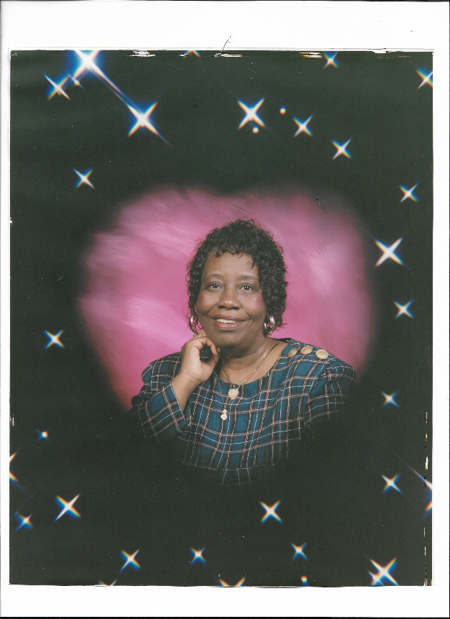
(September 30, 1948 - November 3, 2021) – Mrs. Annie Louise Benn Jones, affectionally known as Ann, was born on September 30, 1948 in Columbia, SC. She was the daughter of the late Sam and Mattie Lee Benn. Surrounded by her family, she entered into eternal rest on Wednesday, November 3, 2021, at Prisma Health Richland.
Mrs. Jones attended school in Richland County. She graduated from Booker T. Washington High School. Mrs. Jones also attended Greenville Technical College, where she received as Associate Degree in Public Science. She was employed with the Badcock Center of Columbia, SC, for many years until her health declined.
Mrs. Jones was baptized at Central Baptist Church in Columbia, SC. She was also a member of the Order of the Eastern Star.
Mrs. Annie Louse Benn Jones leaves to cherish her precious memory: her sons, Jimmie (Ellen) Singleton, Jr. and Deacon Timmie (Shelia) Singleton, both of Columbia, South Carolina; a daughter, Sonja (Ronald) Anderson, of Columbia, SC; two sisters, Shirley Benn-Anderson and Lovern Benn, of Columbia, SC; two children whom she loved like her own, Chauncey and Heidi Hardrick, of Columbia, SC; twenty grandchildren; eleven great-grandchildren; a host of nieces, nephews, other loving relatives, and caring friends, all of whom will miss her dearly.

