Carolyn Davis 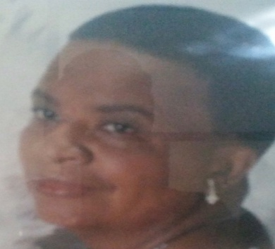
JUNE 14, 1951 ~ JANUARY 12, 2019 (AGE 67)

Service for Carolyn Davis will be held
Friday, January 18, 2019 at 1:00 p.m.
Central Baptist Church
Rev. Dr. Ricky Ray Ezell, Sr. Officiating
Bostick Tompkins
2930 Colonial Dr.
Columbia, SC 29203
Carolyn Brannon Davis was born on June 14, 1951 in Irmo, SC. She departed this earthly life on Saturday, January 12, 2019. She was the beloved daughter of Alberta Brannon and the late James Samuel Brannon Sr.
Carolyn was a graduate of Irmo High School. After graduating she had the passion for working with children and cooking in the childcare field.
“Calyn”, as she was known by her closet family members, was the life of the party and your personal comedian. She was the most selfless, blunt person you’ve ever met.
Everyone that knew Carolyn knew she had a huge heart, cared for anyone she crossed paths with, and was always a go-getter no matter what.
Carolyn was preceded in death by her father, James Samuel Brannon Sr. and her loving bother, James Rudolph Brannon.
She leaves to cherish her loving memories her daughter, Shayla Darby of Irmo, SC; her mother, Alberta Brannon of Irmo, SC; her grandchildren, Jaimerius Williams, and Heaven Williams of Irmo, SC; her sister, Roseta Leaphart of Irmo, SC; Gloria Scott of Columbia, SC, and Ralph Brannon of Irmo, SC; her best friend Marvie Quattlebaum; and a host of aunts, nieces, nephews, cousins, and friends.

