**Upcoming Events**

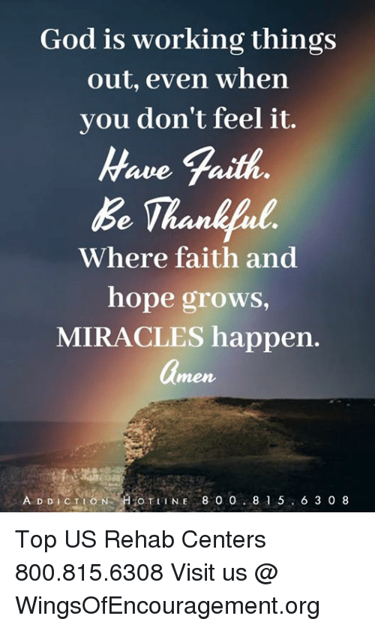



***Order of Service***

***December 6, 2020***

**10:00 am**

***Call to Worship…………………………………………………………………..*Pastor Ezell**

***Prayer ………………………………………………………………………*Pastor Ezell**

***Choral Response………………………………………O Come Let Us Adore Him***

**HHh**

***Praise & Worship………………………………………………………………*Praise Team**

***Tithes & Offerings…………………………………………………….*Trustees & Ushers**

***Selection……………………………………………………………………………*Praise Team**

***Scripture………………………….Psalm 23:1-6 ……...……………………*Minister**

***Selection…………………………………………………………………..*Praise Team**

***The Preached Word - Pastor Ezell***

**“God Is Working It Out For You”**

***Invitation to Discipleship……………………………….…Let Jesus Fix It For You***

***Benediction………………………………………………………………..*Pastor Ezell**