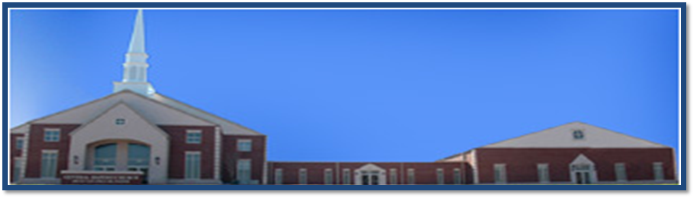
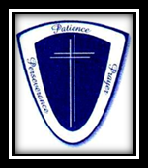
Sunday
Early Worship Service……….8:00 am
Sunday School………………10:00 am
Morning Worship Service…..11:00 am
4th Sunday Evening Bible Study ….5:00 pm
Wednesday
Noon Day Bible Study…..12:00 – 1:00 pm
Evening Bible Study……6:00 pm
Youth Bible Study……6:00 pm

Ricky Ray Ezell, Sr. ~~ Senior Pastor
B.S., M.S., M.Div. D.Min.
3625 Clement Road ~~ Columbia, SC 29203
Office: (803) 252-3742 Fax: (803) 252-6555
Web Address: centralbaptistcolumbia.org
Email: info@centralbaptistcolumbia.org

