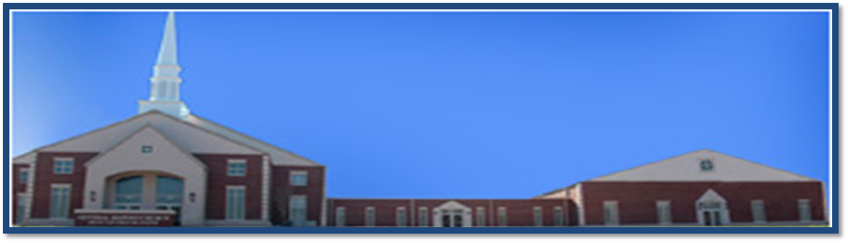

**Sunday**

**Early Worship Service……….8:00 am**

**Sunday School………………10:00 am**

**Morning Worship Service…..11:00 am**

**4th Sunday Evening Bible Study ….5:00 pm**

**Wednesday**

**Noon Day Bible Study…..12:00 – 1:00 pm**

**Evening Bible Study……6:00 pm**

**Youth Bible Study……6:00 pm**

**Ricky Ray Ezell, Sr. ~~ Senior Pastor**

**B.S., M.S., M.Div. D.Min.**

**3625 Clement Road ~~ Columbia, SC 29203**

**Office: (803) 252-3742 Fax: (803) 252-6555**

**Web Address: centralbaptistcolumbia.org**

**Email: info@centralbaptistcolumbia.org**