Ministerial Staff

Senior Pastor
Rev. Dr. Ricky Ray Ezell, Sr.

Associate Ministers
Rev. Leon Dickerson
Rev. George Harper
Rev. Winslow Harrison
Rev. Lawrence McCarter
Rev. Flossie Montgomery
Rev. Kenneth Wilson
Rev. Dr. Carson Wise

Administrative Staff
Cynthia Brown
Church Secretary

Bernice Ezell
Administrative Assistant

Cathy Phelps
Business Manager

Verna Isaac
Custodial

Earl Brown
Custodial/Security

George Wright
Security

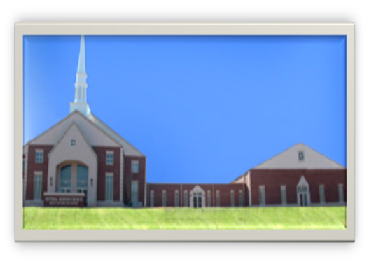

Musical Staff

Byron Dixon

Anthony Outen

Courtland Thomas

Elaine Black
Voice

Brandon Brown
Percussionist

Sam Cornelius, Sr.
Percussionist

Our Staff

