Deacon Anthony Tyrone Scott

(January 24, 1958 – January 5, 2019)

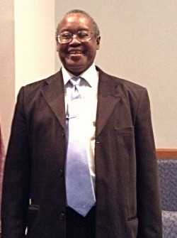

Viewing Location: Leevy' s Funeral Home, Taylor Street Chapel
Viewing Date and Time: Friday, 01/11/2019, 2:00 p.m.
Funeral Location: Central Baptist Church
Funeral Date and Time: Saturday, 01/12/2019, 11:00 a.m.
Interment Location: Memorial Gardens of Columbia
Funeral services for Deacon Anthony Tyrone Scott will be held Saturday at 11:00 a.m. at the Central Baptist Church with burial in Memorial Gardens of Columbia. Viewing will be held Friday beginning at 2:00 p.m. at the Leevy’s Funeral Home, Taylor Street Chapel.
Surviving are his wife, Priscilla Conner Scott; sons, Joshua (Latasha) Scott and Erick Conner; mother, Mary Lee Sims Scott; brothers, Darryl Scott and Keith (Yolanda) Scott; three grandchildren; other loving relatives and friends.

