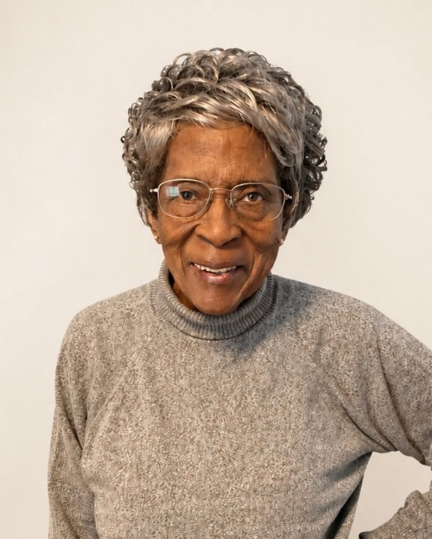September 19, 1928 ~ June 28, 2026 (age 97)

Sarah Wilson Obituary
Service for Mrs. Sarah A. Wilson, 97, of Columbia, South Carolina will be held July 6, 2026 Monday at 12:00 noon in the Central Baptist Church 3625 Clement Road Columbia, South Carolina. Sarah Alice Brown was born on September 19, 1928, in Fort Motte, South Carolina, to the late Gervais Brown and Evangeline Pickney Brown. She peacefully departed this life on Sunday, June 28, 2026. She received her education at Wilkinson High School in Orangeburg, South Carolina. On March 20, 1954 she was united in holy matrimony to Deacon Leroy Wilson, Sr. (deceased) in Columbia, South Carolina. Their loving union was blessed with four children: Gloria, Loretta, Leroy Jr., and Curtis . They shared sixty-six beautiful years of marriage until his passing preceded hers. At an early age, Sarah Wilson accepted Jesus Christ as her personal Lord and Savior. She served faithfully as a Deaconess at Central Baptist Church in Columbia, South Carolina, until her illness, She joyfully participated in the Missionary Ministry and Golden Voice Choir. Deaconess Wilson was a devoted mother, a pillar of strength, and a cherish presence in the lives of all who knew her. She leaves to celebrate her life and legacy: Her daughters, Gloria Wilson and Loretta Wilson Harrell, both of Columbia, SC; Her sons Leroy Wilson Jr. (Maxine) and Curtis Wilson (Bridget) both of Atlanta, GA; Seven grandchildren; Eight great -grandchildren; Three great-great-grandchildren; And a host of loving relatives and caring friends. ( Her memory will forever remain a blessing to all who loved her.)

