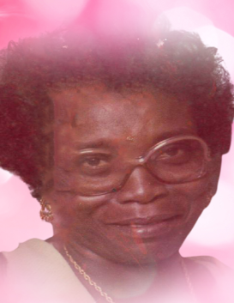
Girtharean "Ms. T" Castile
March 6, 1927 ~ November 30, 2021 (age 94)
Obituary & Services
Tribute Wall

Obituary
Girthanian Castile was born on March 6, 1927 and departed this life on November 30, 2021 at 4:35 at Prisma Health Richland. She was educated in the Aiken County Public Schools. She loved the Lord and served him faithfully. She was a member of Central Baptist Church and served on the Missionary Ministry, Usher Ministry, and the Ronald D. Barton Mass Choir. She worked various positions throughout South Carolina State Government where she retired. After retirement, she provided private duty home and business services.
Mother Castile had a passion for cooking and baking. She had the BEST FOOD EVER! Gardening was her life and she loved to go fishing.
Mother Castile was married to Odell Lane, who departed this life young, then she married John Castile.
Mother Castile was preceded in death by both husbands; a daughter; her only son, James Clyde Livingston, Sr and a daughter in-law, Essie Patricia Johnson Livingston.
Those left to cherish her memories are her grandchildren, Elaine Blanding, James Livingston, Jr, Kenny (Alethea) Liverman, Santago (Jaquanda) Daniels, Catrina Watts, all of Columbia, SC, and Troy Bolton of Florida; great-grandchildren, Shemicka Blanding, DeMondre Blanding, Janice Canzater, LeAngela Blanding, Trimentra Best, LaMontae Bostick, Jieshakia Best, Kenneth Liverman, Jr, Shakira Craft, Jodi Scott, LaCresisha Bostick and other great-grandchildren; forty-five great-great-grandchildren:, Patrick Middleton, whom she loved like a son and a host nieces, nephews other loving relatives and friends.
Mother Castile great-great granddaughter Shemicka and Shemicka’s children, Tatyana Blanding, Danaijah Williams, DaeTarius Williams, Amya Howard and Carmen Spann took great care of Mother Castile and provided love and support.
Mother Castile will truly and deeply be missed by her family.

