July 23, 1945 ~ April 18, 2025 (age 79)

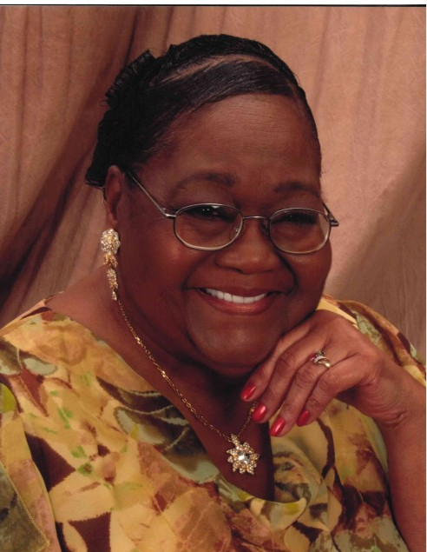 Gwendolyn Eugenia Burton Bostick
James and Mary Louise Richardson Burton proudly welcomed Gwendolyn Eugenia Burton Bostick into their home, lives, and hearts on July 23, 1945. Gwendolyn departed this earthly life at her residence on Friday, April 18, 2025, in Columbia, South Carolina.
Gwen, as she was affectionately called by family and friend, was raised in Columbia, where she attended the public schools of Richland County, graduating from C. A. Johnson High School in 1963.
Gwendolyn had a fulfilling career at Southern Bell for over 25 years. After retiring, she joined the Department of Youth Services and worked part-time at Dillard's Department Store and Wal-Mart.
Gwen united in holy matrimony with Philip Lee Hingleton, and together they had four children. She later married Lee Otis Bostick of Columbia, who preceded her in death.
Gwendolyn became a member of Central Baptist Church, where she enjoyed Bible study. She read her bible daily and often spoke fondly of her opportunity to visit the Holy Land with her church family.
She was an avid Clemson football fan. We will miss her home cooking and cake baking. She will be missed by all those whose lives she has so lovingly touched.
Gwen was preceded in death by her parents, and three Loving Brothers, Robert Sherell, Louis Monroe Burton, and David Earl Burton.
Gwen is lovingly survived by her children, Philip Lee (Monica) Hingleton Jr.; Rhonda Lavern (Jeffrey) Anthony both of North Carolina; James Matthew (Regina) Hingleton of Columbia, SC; and Robin Lanier Hingleton of Columbia, SC; her sister, Deborah Ann (Charles) Cherry; and brother, Charles Anthony Burton, both of Columbia, SC. Additionally, Gwen cherished her grandchildren, great-grandchildren, nieces, nephews, cousins and other loving relatives and dear friends, all of whom will dearly miss her.

