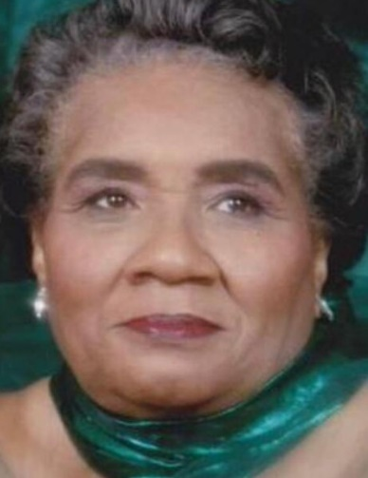 Hattie Harrison Wilson
June 10, 1932 ~ March 15, 2024 (age 91)

Hattie Wilson Obituary
Service for Mrs. Hattie Harrison Wilson, 91, of Columbia, South Carolina will be held on Saturday March 23, 2024 at 11:00 am at the Central Baptist Church 3625 Clement Road Columbia, South Carolina. Burial will be at Memorial Gardens of Columbia 9301 Wilson Blvd. Columbia, South Carolina. There will be a viewing on Friday from 12:00 to 7:00 at Pearson's Funeral Home 4508 N. Main Street Columbia, South Carolina Mrs. Wilson will lie in-state at the church on Saturday from 10:00 to 11:00 am. She was born in Fairfield County the daughter of the late Carlton Taylor and Fannie Harrison on June 10, 1932. Mrs. Wilson was a long time member of the Central Baptist Church and the Missionary Society, Golden Voices, Catering Ministries and many more. She is survived and cherish by her loving daughters, Commie Holmes of Columbia, SC, Belinda Edwards of Irmo, SC, Andrea (Payton) Johnson of Whitaker, MI. Carol Wilson, Jenny (Henry) Scott, Paula Wilson all of Columbia, SC, Meldrina Edwards of Dumfries, VA., and sons, Rev. Kenneth (Patricia) Wilson of Gaston, SC, Larry (Carla) Wilson of Southfield, MI, Ronnie Taylor, Sr., Nathaniel Wilson, Andrew Wilson all of Columbia, SC, Doyace (Tawanna) Wilson of Tucson, Arizona, twenty six grandchildren, fifty seven great grandchildren and eleven great great grandchildren. and one sister Henrietta Taylor of Columbia, SC,a host of uncles, aunts, nieces, nephews, cousins and other relatives and friends who loved her dearly.

