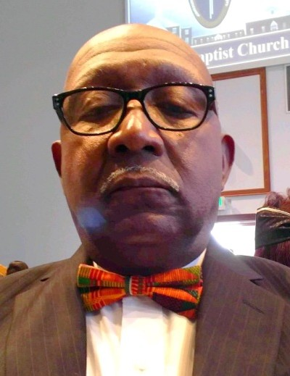Mr. Herbert McDuffie, Jr.
March 18, 1949 ~ April 6, 2020 (age 71)
Obituary & Services
Tribute Wall
Obituary
Herbert McDuffie, Jr., was born March 18, 1949 to Jack and Alice McDuffie. On Monday, April 6, 2020 our Heavenly Father called him home.
Herbert was educated in Richland County schools and graduated from Bethel High School in 1967. After graduating, he served in the US Army where he earned numerous medals, unit awards, and citations under FOIA. Herbert later went down another career path and worked at Wells Fargo Bank where he retired after 30 years.
Herbert was an active member at Central Baptist Church, where he served on the Men’s Choir and the Deliverance of Praise. Herbert enjoyed listening to the blues, gospel, and spending time with his family and friends.
Herbert married the love of his life, Dorothy Bell Nelson-McDuffie, on May 11, 1971 and they were blessed with two sons, Herbert “Trey” McDuffie, III and Matthew McDuffie.
Herbert was preceded in death by his father, Herbert “Jack” McDuffie., Sr.; son, Herbert “Trey” McDuffie, III; and brothers, Andrew, Leon and Frank McDuffie.
Those left to cherish his loving memory are his wife, Dorothy Bell Nelson-McDuffie; son, Matthew McDuffie; two grandsons, Hasshan McDuffie and Tra`von McDuffie, both of Columbia, SC; mother, Alice McDuffie of Lugoff, SC; brothers, Larry McDuffie of Columbia, SC and Donald (Denise) McDuffie of Columbia, SC; three sisters, Thelma (Fred) Allen of McDonough, GA, Galle (Edgar) Higgins of Columbia, SC, and Deborah McDuffie of Locust Gove, GA; four sisters-in-law, Essie (James) Barelay of Columbia, SC, Brenda (Ruthledge) Pearson of Penniscola, FL, Lena Hendricks of Kansas City, MO, and Margret Hallman of Columbia, SC; two brothers-in-law, Jonny Nelson of Brooklyn, NY and James Nelson of Philadelphia, PA; and a host of loving family and friends who will miss him dearly.

