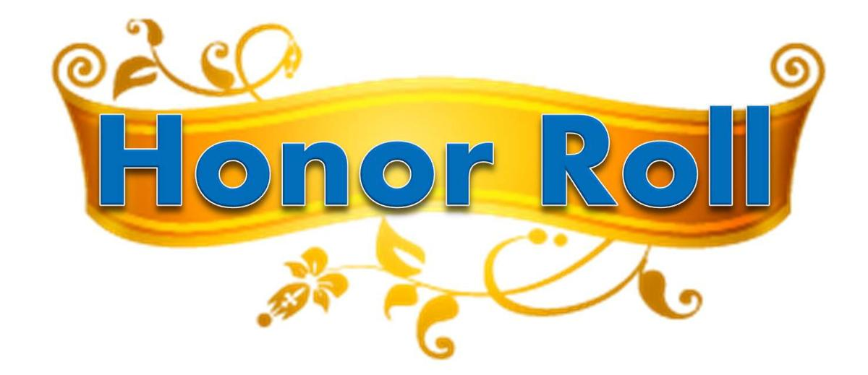
CENTRAL BAPTIST CHURCH
2020 – 2021 School Term
4th Marking Period

Kendrell Chambers

Ken’ya Williams Fanning

Laurin Hannibal

Nasir Jackson

Feasia Lake

Zaria Lake

Charles Price

I’Rihaunna Wheatle

