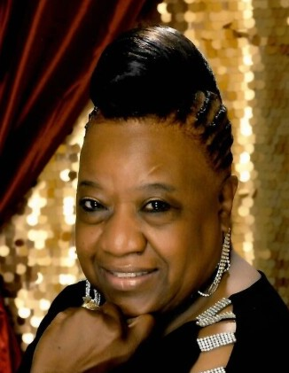
Obituary
Juanita Hill Wilson was born on November 4, 1948, to Helen Williams and William Hill in Columbia, South Carolina. She passed away peacefully at her home on the morning of January 19, 2022, in Columbia, South Carolina.
Juanita attended the public schools of Richland County and was a proud graduate of Booker T. Washington High School, Class of 1967. While at Booker T. Washington High School, she was voted Most Popular and Most Talented by her classmates during her senior year. She was also a majorette on the BTW Marching 100. Juanita furthered her education by attending Allen University in Columbia, South Carolina. There she received many awards and recognition on her way to receiving her Bachelor’s Degree in English Education. She pledged Sigma Gamma Rho, Inc. and was chosen as Miss Sigma Gamma Rho and Miss May Queen during her senior year. Juanita received her Master’s Degree from the University of South Carolina in Reading Education.
While Juanita was a freshman in high school, she met the love of her life, Woodrow “Woody” Wilson. This would be the beginning of a life-long journey that encompassed their love story that lasted from that day until the day of her passing. Juanita and Woodrow were married on March 24, 1972, and would have celebrated their “Golden” 50th Anniversary in just a few short weeks. Everyone who knew the couple personally would refer to them as “Woody and Juanita .”From their marriage, they were blessed with one beautiful daughter, Shayla Juanita. She was Juanita’s crowning glory and the light of her life. She celebrated each of Shayla’s accomplishments. Shayla later blessed her parents with one grandchild, Kyndall Juanita Riley, who was the spitting image of her mother and grandmother.
Juanita’s career spanned over 49 years as a teacher with Richland County School District One. She loved every aspect of being a teacher. She loved and mentored many of her fellow teachers. She also cared deeply for all of the staff members she worked with. However, nothing was more important than the thousands of students that she shared the educational experience with. She gave herself to her students wholeheartedly and was often a leader, counselor, and mother to many of them throughout the years.
Juanita was a member of Friendship Baptist Church in Columbia, South Carolina, where she served faithfully as a trustee for many years. She later joined Central Baptist Church in Columbia, South Carolina, where she served with the Education Ministry faithfully until her passing. She was a deeply devoted Christian, and she was totally committed to her faith.
In addition to her parents, Juanita was preceded in death by her siblings, Willie Mae Hill Goodson, Louise Hill Goodson, Robert Louis Hill, Mary Helen Hill Goodson, Samuel Bernard Hill, and Linda Joyce Hill Austin.
Juanita leaves to cherish her precious memories her husband, Woodrow Wilson; daughter, Shayla Juanita Wilson Riley; granddaughter, Kyndall Juanita Wendy Riley; sister, Ernestine Hill (Samuel) O’Berry; and a host of loving nieces, nephews, extended family, and friends.

