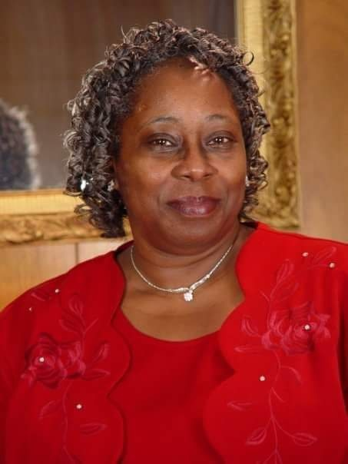

Lucy Ann Counts Glenn was born in Columbia, SC on September 24, 1950, to the late Louis Counts and Lucy Ann Barnes Counts. She attended public school in Richland County, SC and graduated from Booker T. Washington High School in 1968.

Lucy Ann worked as a radiology clerk at Richland Memorial Hospital and retired as a nurse's aide from the South Carolina Department of Mental Health and the Brian Center of Columbia. She was a member of the Health and Wellness Ministry and the Gospel Choir at Central Baptist. She loved to sing, listen to gospel music and spend time with her children and grandchildren.
She leaves to cherish her memories: daughters, Cheryl Vance (Walter), Pamela Lewis (Edward), and son Mark Glenn II (Naquava); grandchildren, Ashley Glenn-Banks, Malachi Lewis, Danyel Hogsett, Marcellus Lewis, Ayden Glenn, Elijah Glenn and Ava Glenn; great-grandchild, Malia Washington; best friend Irma Brantley and a host of nieces, nephews, other family members and friends.

